PRINCE WILLIAM COUNTY ALUMNAE CHAPTER OF DELTA SIGMA THETA SORORITY, INC.

A Public Service Sorority
Presents the
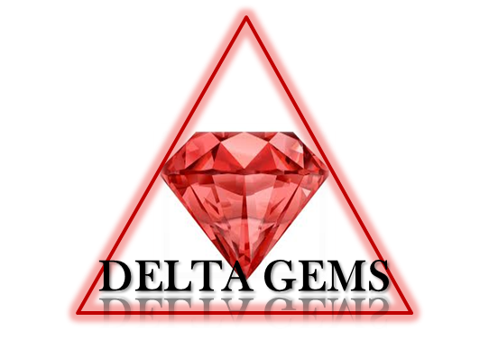
DELTA GEMS PROGRAM 2024-2025 PARENT & PARTICIPANT INFORMATION PACKET
DELTA GEMS (Growing and Empowering Myself Successfully)
To Delta GEMS Parents & Participants:

Welcome to the 2024-2025 Delta GEMS Program year. Attached, please find IMPORTANT program information. All participants (new and returning) must complete the application packet.

To participate in the GEMS program, you must be at least 14 years old (by October 20, 2024) and a freshman in high school.

This Information Packet includes guidelines, authorizations, and permissions that are critical to the success of the program and care of our participants. It is absolutely imperative that the required documents be returned by Sunday, October 6, 2024. Parent/Participant authorizations must be received by this date to participate in this year’s program.

Please email your packet with the following subject line: PWCAC 2024-2025 Application Packet for (GEM’S Name) to (pwcacdstgems@gmail.com)

The Checklist is provided as a tool to assist in ensuring all required signatures and forms are returned.

We are looking forward to a productive and exciting year!

Respectfully,

Prince William County Alumnae Chapter
Delta GEMS Co-Chairs
Karla Sidner
314-503-1191
Gina Carrell
678-656-9393

Email: pwcacdstgems@gmail.com

CHECKLIST
PARENTAL AFFIRMATION/WAIVER AND RELEASE (Signature Required) _______

CODE OF CONDUCT (Signature Required) _______

CONTACT INFORMATION/PREFERENCE DATA (Information Required) _______

YOUTH INITIATIVE VIRTUAL MEETING/EVENT PARTICIPATION
AGREEMENT (Signature Required) _______

SIGN-IN/SIGN-OUT POLICY (Information Only) _______

YOUTH PICK UP AUTHORIZATION FORM (Signature Required) _______

FIELD TRIP PERMISSION (Signature Required at Time of Activity) _______

MEDICAL INFORMATION FORM (Information Required) _______

EMERGENCY MEDICAL TREATMENT
AUTHORIZATION (Information Required) _______

HEALTH INFORMATION (Information Required) _______

NON-PRESCRIPTION MEDICATION PERMIT (Signature Required) _______

EMERGENCY CONTACT INFORMATION (Signature Required) _______

MEDICAL AUTHORIZATION FORM (Physician’s Signature) _______

PARENTAL PERMISSION FORM - ADMINISTRATION OF
PRESCRIPTION MEDICATION (Signature Required) _______

MEDICATION ADMINISTRATION PROCEDURE (Information Only) _______

CONFIDENTIALITY POLICY (Information Only) _______

PHOTOGRAPH AND VIDEO AUTHORIZATION
AND RELEASE FORM (Signature Required) _______

CONTACT INFORMATION & PREFERENCE DATA
(PLEASE PRINT ALL FIELDS)

CONTACT INFORMATION
Participant Name & Age_________________________________________________________
(MUST BE 14 BY OCTOBER 20, 2024)

Participant Email Address________________________________________________________

Participant Cell Phone #__________________________________________________________

Participant High School & Grade Level______________________________________________

Parent/Guardian Name___________________________________________________________

Parent/Guardian Email Address____________________________________________________

Parent/Guardian Cell Phone # _____________________________________________________

Parent/Guardian Name____________________________________________________________

Parent/Guardian Email Address_____________________________________________________

Parent/Guardian Cell Phone #_______________________________________________________

T-Shirt Size______________________________________________________________________

PARTICIPANT PREFERENCE DATA

Please check the workshops/activities you would be interested in attending.

Public Speaking

College Fair (Preparing & Applying for College, Scholarships & College Life)

Money Management/Saving

Time Management/Organizing & Study Habits & Homework Tips

Book Club (Books related to Teen Issues)

Physical & Mental Health (Nutrition, Exercise, Self-Esteem, Health & Beauty)

Resume Writing/Job Interviewing Tips

Retreat (Wellness/Loving Myself)

Other ________________________________________________________________________

